Question 1:
https://leetcode.com/problems/power-of-two/submissions/2191420347/
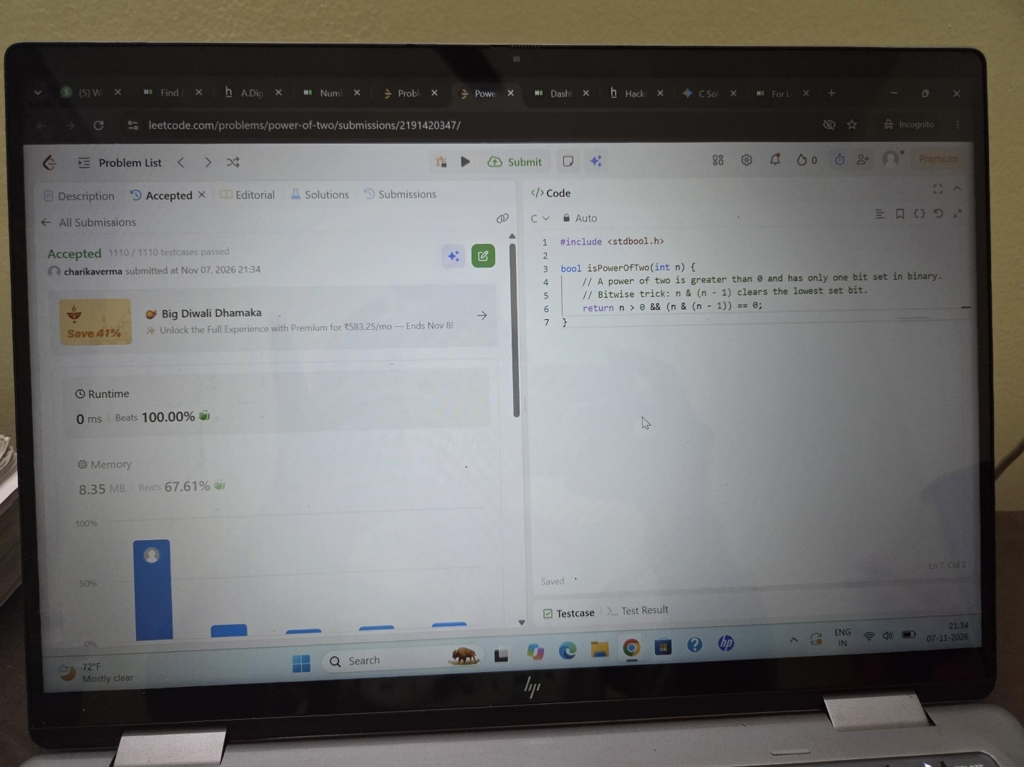

Question 2:
https://leetcode.com/problems/power-of-three/submissions/2191420932/
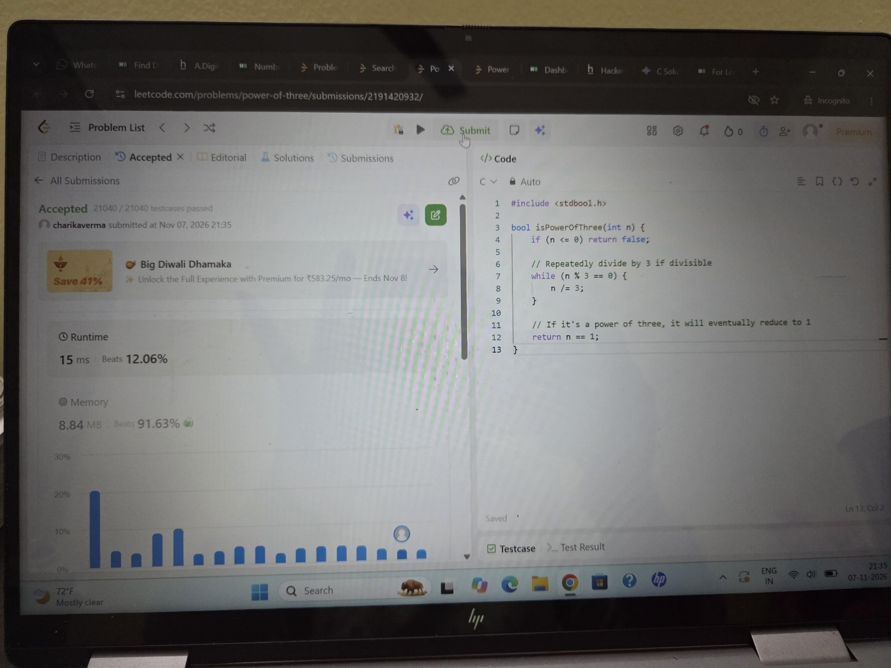

Question 3:
https://www.hackerearth.com/practice/basic-programming/input-output/basics-of-input-output/practice-problems/algorithm/find-factorial/
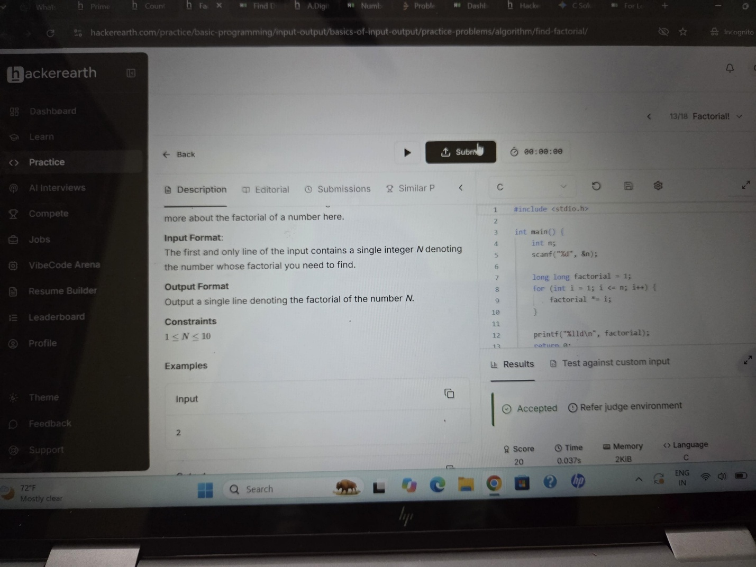

Question 4:
https://www.hackerearth.com/practice/basic-programming/input-output/basics-of-input-output/practice-problems/algorithm/count-divisors/
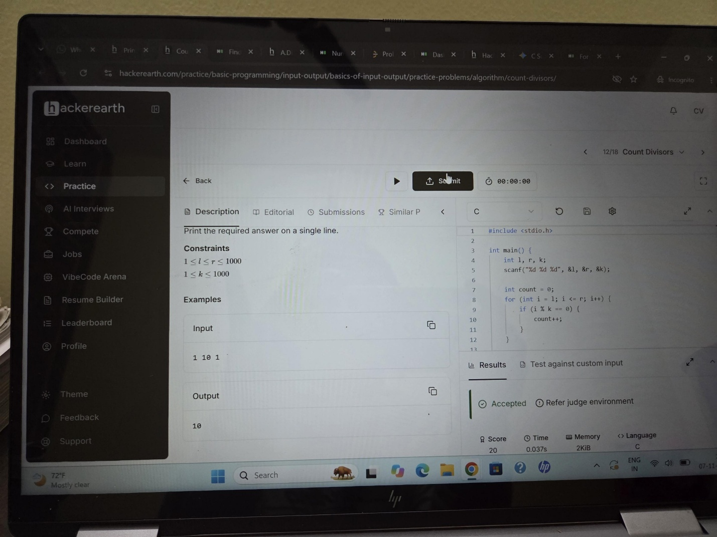

Question 5:
https://ackerearth.com/problem/algorithm/prime-numbers/
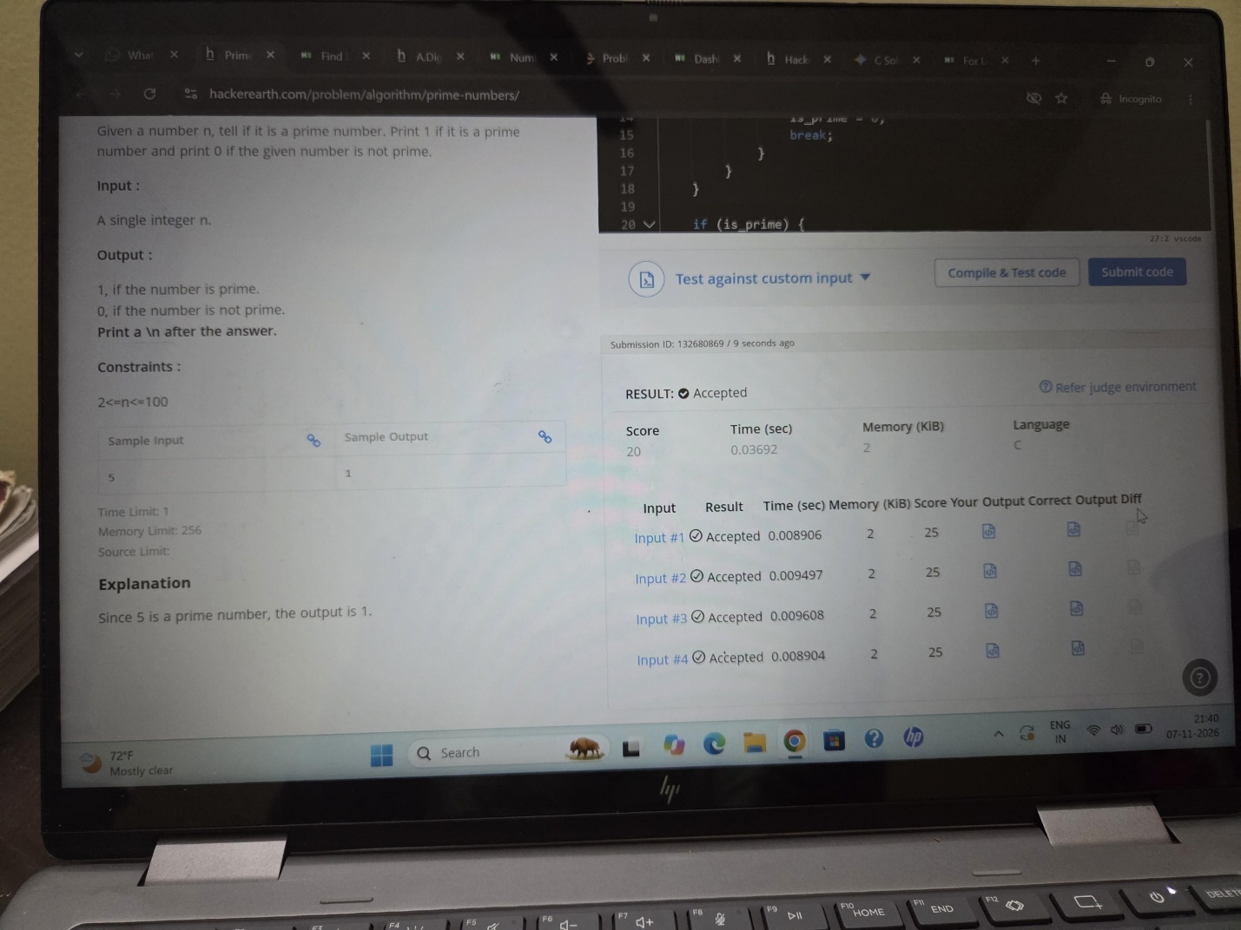

Question 6:
https://leetcode.com/problems/perfect-number/submissions/2191424316/


